Deborah Barndt

ITMD 455-02: Android App

Lab 7

James Papademas

4-12-17

Snapshot of Logcat showing the rating column:

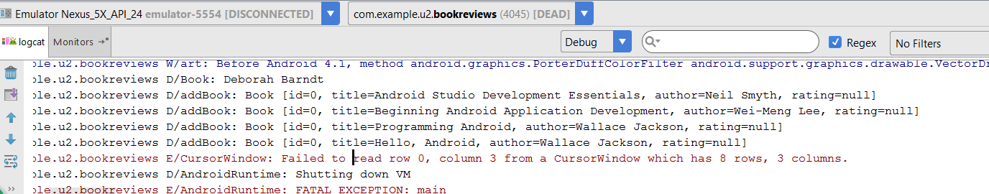

Snapshot of updated table with rating:

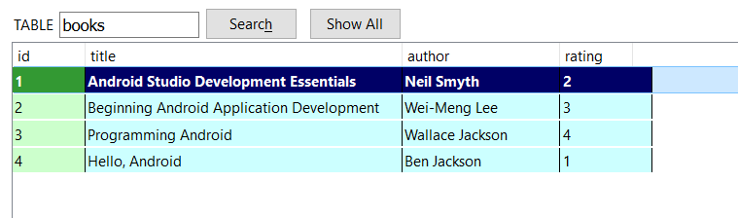

Snapshot of Book List Display:

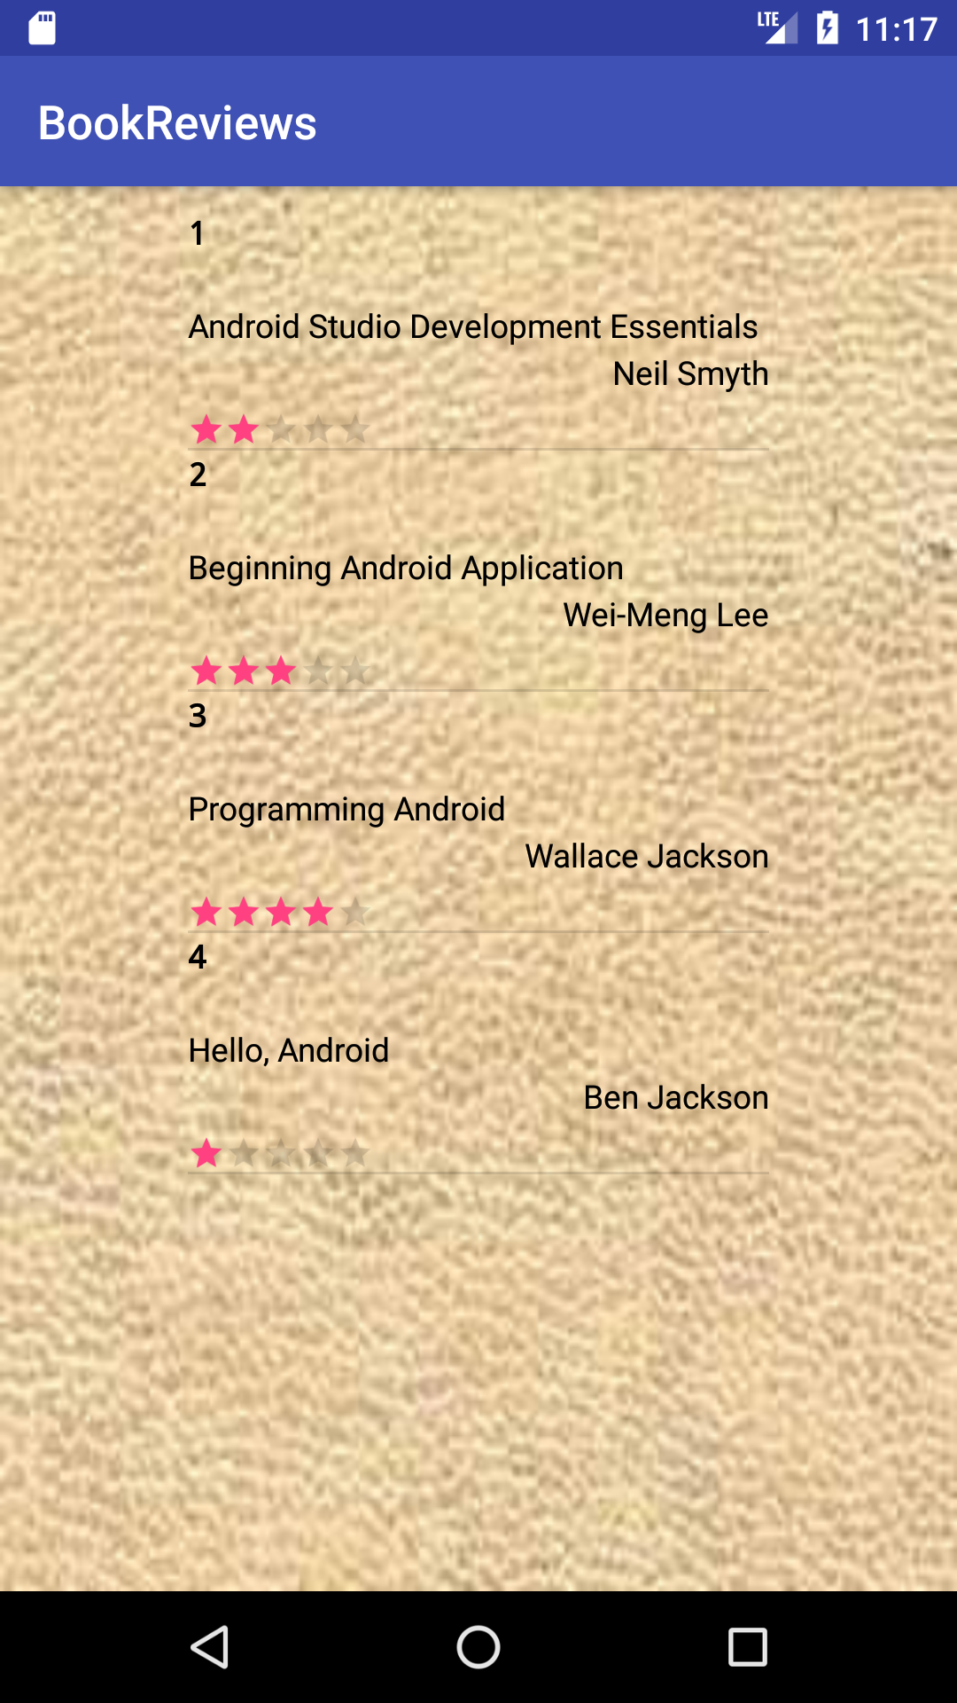

Snapshot of logcat file with the books displayed:

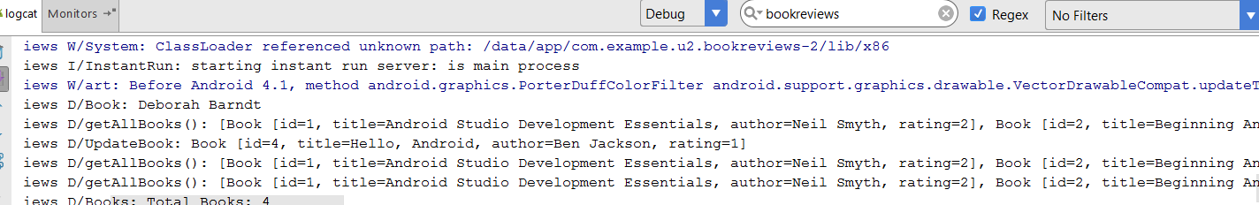

Snapshot of BookReviews Display with Book Images and changed background texture (decided I didn’t like the leather texture cause a little hard to read):

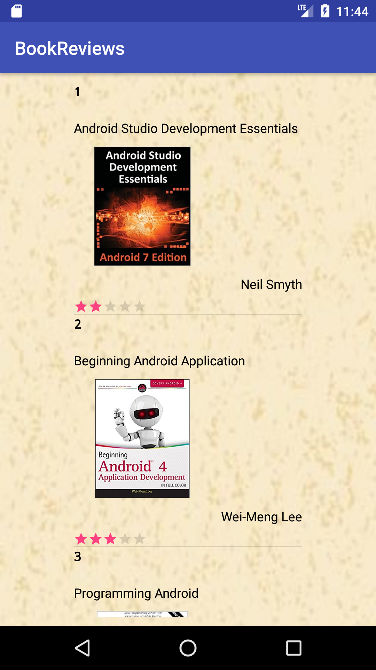

Snapshot 2 of the BookReviews Display with Book Images:

